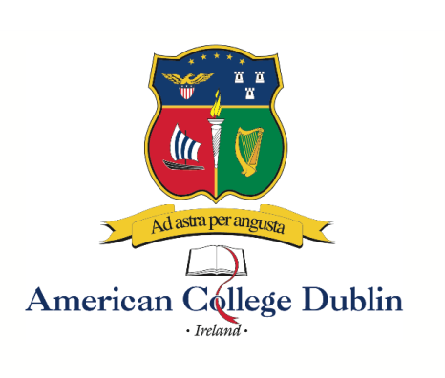
Summer 2023 Inclusive Programs
ALL ACD Summer Programs Include the following:

Tuition – Programs are 2, 4, or 6 weeks, so you take 1, 2, or 3 classes, depending on which program you choose. You earn 3, 6, or 9 credits. ACD will send an official transcript to your home school in the US at the end of the summer program.

Accommodations – Students should plan to arrive in Dublin on the posted Saturdays. Residence center check-out is on Friday. There’s no rule stating you must return home that day. You can explore the Emerald Isle, backpack through Europe, or perhaps your family will join you for a holiday. You might also make private arrangements to stay on at the residence center.

Meals – Daily breakfast is included at the residence. A boxed lunch is provided on campus on class days. Dinner is on your own; unfortunately the residence facility does not have a kitchen, so all evening meals must be ordered. The program also includes a Welcome Dinner and a Farewell Celebration evening.

Airport transfers – ACD will arrange for transportation from the Dublin airport to the accommodations on the specified arrival dates, as well as return transportation back to the Dublin airport on the corresponding check-out dates.

Day trips – Depending on the calendar, and other factors, you might visit Howth or Bray, both just outside Dublin. Other possible site visits include the EPIC Emigration Museum, the Little Museum of Dublin, the Jeanie Johnston, a 3-masted barque that transported Irish famine victims to North America. ACD might also take you to see the Book of Kells, the 8th century illuminated (illustrated) book of the Gospels, housed at Trinity College.

On your own, you might want to visit St. James’s Gate, site of the Guinness Brewery. And Temple Bar, one of the most renowned, and most friendly neighborhoods, in Dublin. You could also visit the Dublin Zoo, Phoenix Park, Poolbeg Lighthouse, the General Post Office, where much of the action took place during the Easter Rising of 1916. And Kilmainhaim Gaol, where more than a dozen of the Rising leaders were executed.

On weekends, you might want to explore further afield, visiting the Cliffs of Moher, Galway, Blarney Castle, Belfast. There’s so much to see and do on the wee green island.

Miscellaneous – Also included is student health insurance and ACD’s processing fees. Just after you submit your application, you’ll be asked to pay the $35 (non-refundable) application fee. Upon acceptance, you’ll be asked to pay the $1000 deposit, which is credited towards the total program fee.

Additional costs – Students are also responsible for their airfare, books (perhaps $150 for the full summer), and personal spending money. A reasonable estimate is $1200 - $1500/month, since you’ll be paying for all of your evening meals, ymmv.

