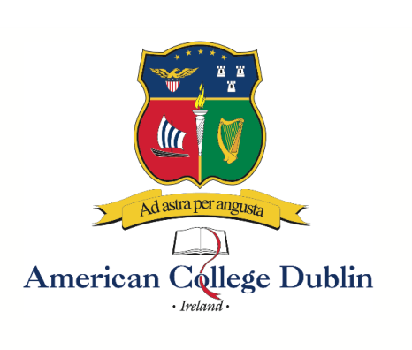

Summer 2023 Calendar

Program A 27 May – 7 July 6 weeks 3 courses, 9 credits
Program B 27 May – 23 June 4 weeks 2 courses, 6 credits
Program C 27 May – 9 June 2 weeks 1 course, 3 credits
Program D 10 June – 7 July 4 weeks 2 courses, 6 credits
Program E 10 June – 23 June 2 weeks 1 course, 3 credits
Program F 24 June – 7 July 2 weeks 1 course, 3 credits

Irish Culture and History Program
1 course, 3 credits, 2 weeks

26 June – 6 July
OR
10 July – 20 July

Programs A, B, C
Residence center check-in Saturday, 27 May
Orientation Saturday & Sunday, 27-28 May
Classes start Monday, 29 May

Program A
Residence center check-out Friday, 7 July

Program B
Residence center check-out Friday, 23 June

Program C
Residence center check-out Friday, 7 July

Programs D, E
Residence center check-in Saturday, 10 June
Orientation Saturday & Sunday, 10-11 June
Classes start Monday, 12 June

Program D
Residence center check-out Friday, 7 July

Program E
Residence center check-out Friday, 23 June

Program F
Residence center check-in Saturday, 24 June
Orientation Saturday & Sunday, 24-25 June
Classes start Monday, 26 June
Residence center check-out Friday, 7 July

Class schedule: Monday – Thursday, 10am – 2pm. With the exception of site visits.

American College Dublin
Summer 2023 Courses

Course Group I: Programs A, B and C (select one course)

LIB480 Irish cultural studies
An exploration of aspects of historical and contemporary manifestations of Irish culture. Topics include plays, storytelling, movies, media and literature in Ireland; Irish music from traditional to U2; contemporary Irish architecture and design; socialising and entertainment; fashion, taste and materialism in the era of the Celtic Tiger and the recession. The course makes extensive use through field trips of the cultural amenities of Ireland’s vibrant capital city, Dublin. General education course

LIB402 Oscar Wilde and his circle
Studies the social circle and literary works of Oscar Wilde, the most influential Anglo-Irish writer of the late Victorian era. A bohemian, wit, and conversationalist, Wilde inspired a culturally vibrant social environment in Dublin, London, and Paris, whose legacy has lasted until the present day. Wilde’s artistic achievements in the realm of poetry, fiction, drama, the art of conversation, and literary criticism will be considered in the context of late nineteenth-century aesthetic movement, Irish nationalism, Anglo-Irish colonial relations, the emerging celebrity culture, early Modernism, and Victorian attitudes towards homosexuality. General education course

Course Group II: Programs A, B, D and E (select one course)

LIB485 Dubliners: writing the Irish short story
This courses focus on introducing students to the basics of short story writing, with special reference to the context of Ireland’s capital city. With a combination of reading examples from seminal short story writers, critical work, class-based writing exercises and field trips to sites of literary interest around Dublin, students will learn the form and mechanics of the short story while also working toward developing their own short prose piece. Their first draft will be work-shopped in class, in which constructive criticism and feedback will be given. The final polished pieces of 2,500 words will be submitted for assessment and, possibly, submitted for publication to literary magazines or websites around Ireland. General education course

IB408 Contemporary global challenges
This course concentrates on the recent dynamics of the global environment focusing on the changes in the geopolitical and economic map, the crisis in the Western World, the power of states in market economies, the central role played by innovation and technology in development and the challenging global imbalances, such as commodity markets and environmental issues.

Course Group IV: Programs A, D and F (select one course)

LIB482 History seminar: themes in Irish history
This course examines selected themes and developments in Irish history from prehistoric times to the present. The objective is to develop an understanding of the course of Irish history and its place in the wider European historical experience. Class sessions are conducted in a lecture and discussion format. Student participation requires full and punctual attendance, taking of lecture notes, completion of required reading, involvement in class discussions, and completion of assigned reports on various themes with presentation to the rest of the class. Field trips explore historically relevant aspects of Ireland’s capital. General education course

IB308 Sustainable business
This course will look how creative and sustainable business can tackle environmental and resource problems such as air pollution, climate change, ozone depletion, food supply problems, depleting stocks of fish, fossil fuels, and fresh water. We will review national and international government agencies initiatives such as eco-taxes, recycling policies, environmental taxation, regulations such as the Kyoto Protocol and eco-business opportunities. In this course we will study the main components of sustainable business practices includes sustainable economic theories, modern business practices, cost savings from recycling, reducing power consumption and reusing inputs.

Please note classes and dates subject to change, with or without notice. 17 February 2023

