Irish American University

American College Dublin

STUDY ABROAD

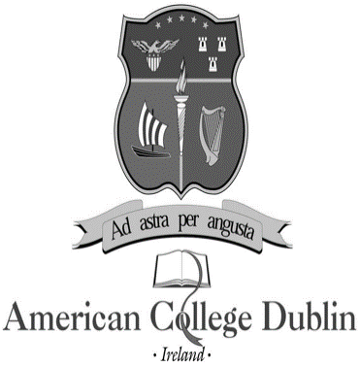

Summer 2024 Programs

**Program Schedule: Monday-Thursday, 10 am–2 pm, with the exception of site visits.**

**Program A 6 Weeks 20 May 2024 – 31 May 2024**

**Program B 4 Weeks 20 May 2024 – 14 June 2024**

**Program C 4 Weeks 17 June 2024 – 28 June 2024**

**Program D 2 Weeks 17 June 2024 – 24 June 2024**

**Program A Six Weeks**

Residence Center check-in Saturday, 18 May 2024

Orientation Program Saturday, 18 May, and Sunday, 19 May 2024

Classes begin Monday, 20 May 2024

Residence Center check-out Friday, 28 June 2024

**Program B Four Weeks**

Residence Center check-in Saturday, 18 May 2024

Orientation Program Saturday, 18 May, and Sunday, 19 May 2024

Classes begin Monday, 20 May 2024

Residence Center check-out Friday, 14 June 2024

**Program C Four Weeks**

Residence Center check-in Saturday, 1 June 2024  
Orientation Program Saturday, 1 June, Sunday, 2 June 2024

Classes begin Monday, 3 June 2024  
Residence check-out Friday, 28 June 2024

**Please note the following course registration requirements:**

* **Program A 9 credits 3 courses**
* **Program B 6 credits 2 courses**
* **Program C 6 credits 2 courses**

**Course Group I Program A and B (select one course)**

**LIB205 Anglo-Irish Writers**

A survey of prominent Anglo-Irish writers, including: Shaw, Joyce, Wilde, Beckett, O’Casey, Swift and Synge. Students will become familiar with a representative sample of twentieth-century Irish literary works, including short story and drama. Literary criticism related to these works will also be covered. *General education course*

**IB492 International business**

An overview of the unique problems faced by firms engaging in international activities; the importance of understanding the foreign economic, social, political, cultural, and legal environment; the mechanics of importing and exporting; joint ventures, franchising, and subsidiaries; international dimensions of management, marketing, and accounting; international financial management; the special problems of multinational corporations; recent problems of the international economic system; country-risk analysis; and the increasing use of counter-trade.

**Course Group II Program A, B and C (select one course)**

**LIB480* Irish cultural studies**

An exploration of aspects of historical and contemporary manifestations of Irish culture. Topics include plays, storytelling, movies, media and literature in Ireland; Irish music from traditional to U2; contemporary Irish architecture and design; socialising and entertainment; fashion, taste and materialism in the era of the Celtic Tiger and the recession. The course makes extensive use through field trips of the cultural amenities of Ireland’s vibrant capital city, Dublin. *General education course*

**LIB402 Oscar Wilde and his circle**

Studies the social circle and literary works of Oscar Wilde, the most influential Anglo-Irish writer of the late Victorian era. A bohemian, wit, and conversationalist, Wilde inspired a culturally vibrant social environment in Dublin, London, and Paris, whose legacy has lasted until the present day. Wilde’s artistic achievements in the realm of poetry, fiction, drama, the art of conversation, and literary criticism will be considered in the context of late nineteenth-century aesthetic movement, Irish nationalism, Anglo-Irish colonial relations, the emerging celebrity culture, early Modernism, and Victorian attitudes towards homosexuality.

*General education course*

**Course Group III Program A and C (select one course)**

**LIB482\*** **History seminar: themes in Irish history**

This course examines selected themes and developments in Irish history from prehistoric times to the present. The objective is to develop an understanding of the course of Irish history and its place in the wider European historical experience. Class sessions are conducted in a lecture and discussion format. Student participation requires full and punctual attendance, taking of lecture notes, completion of required reading, involvement in class discussions, and completion of assigned reports on various themes with presentation to the rest of the class. Field trips explore historically relevant aspects of Ireland’s capital.

*General education course*

*NB – this course will be repeated during the weeks of 10 and 17 July and will be available for study abroad students to take*

**IB408 Contemporary global challenges**

Concentrates on the recent dynamics of the global environment focusing on the changes in the geopolitical and economic map, the crisis in the Western World, the power of states in market economies, the central role played by innovation and technology in development and the challenging global imbalances, such as commodity markets and environmental issues.

**\*Added Cost – Students will be required to pay some local costs for site visits to museums and other attractions and local transport. These costs will not exceed $60 per person per course.**

***Please note classes and dates are subject to change, with or without notice.*** 30 January 2024